Stat 135 Homework 3

1. 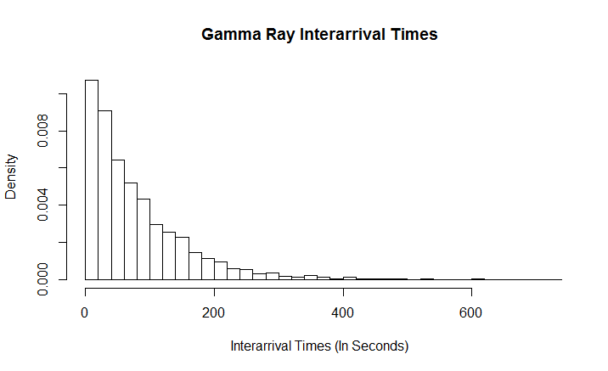 The histogram of gamma-arrivals is presented below.

Given that we are modelling inter-arrival times between particles, it makes sense to assume the particles are arriving independently with some rate λ. This implies an exponential (λ) distribution, and we can see that the histogram looks very similar to the pdf of an exponential random variable. To relax this assumption, we can use the gamma distribution, which is the sum of exponential random variables, to model this data.

Using the method of moments, my calculated estimate for λ is 0.0127 while my estimate for α is 1.0124. The fitted gamma distribution is graphed below on top of the original histogram:

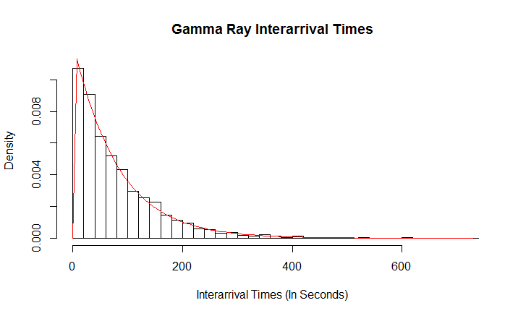

We can clearly see the gamma distribution with the estimated parameters is a good fit for this dataset. It peaks early, and declines as time increases in a similar fashion to the dataset. Moreover, it closely follows the dataset when it gets very thin towards the end.